**WABS Application Manager**

Documentation

I. Installation

1. Create a folder to install the application to. The name and location of the folder does not matter if the files are together. However, putting it in **C:\Program Files** would be preferrable.
2. Extract the .zip file to your folder

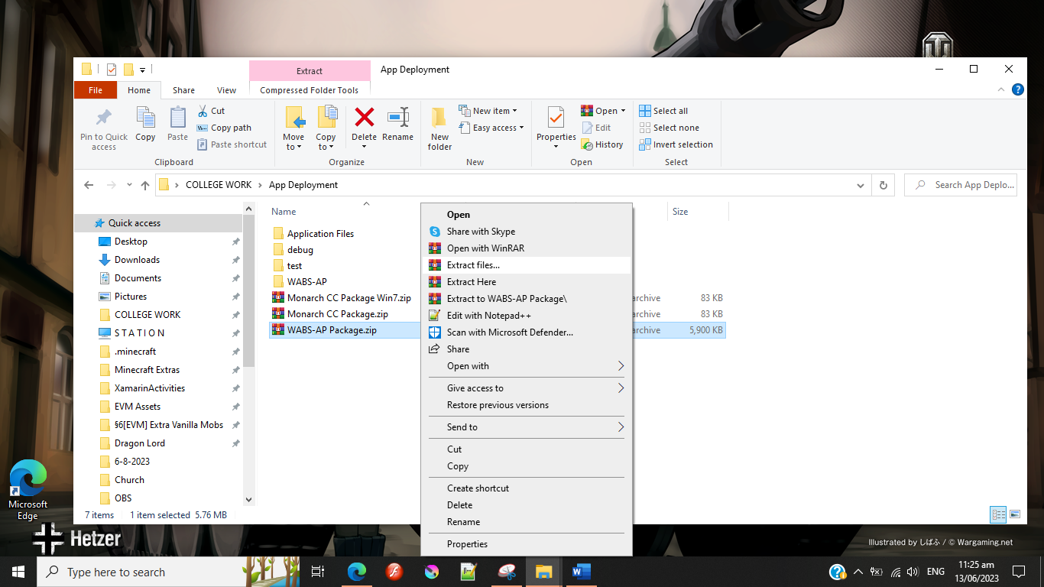

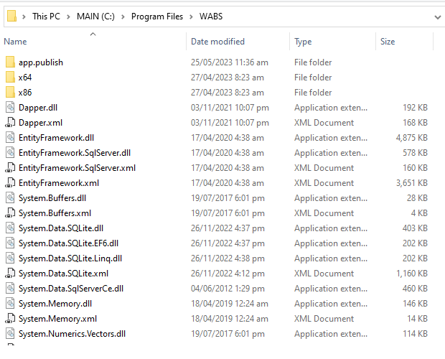

1. 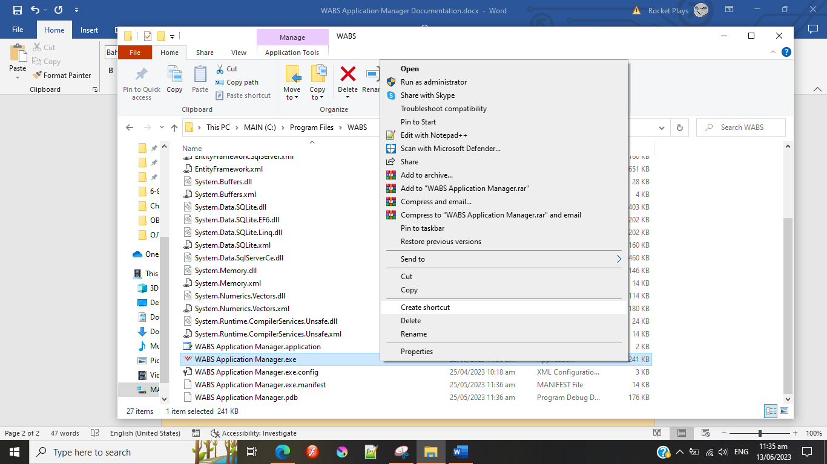Find “WABS Application Manager.exe” and create a shortcut to it. Place the shortcut afterwards in the desktop or wherever you see fit.

II. Database File

The database file is automatically generated in the C:\ directory. You can find it in **C:\WABS Database**.

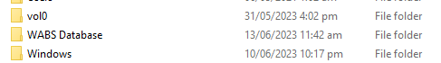

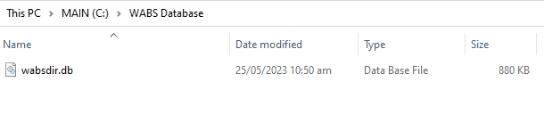

The application can only read and write on the wabsdir.db file if it is located inside the **C:\WABS Database** folder and uses the exact same name (wabsdir.db).

When moving your database to another computer/laptop, copy the latest wabsdir.db file and transfer it the other computer/laptop under the same namespace, **C:\WABS Database\wabsdir.db**

When creating back-up copies of the database file, take note of the date. When renaming database files, do not replace existing .db files with the same name. Use different names for every back-up created. Feel free to create folders within the C:\Wabs Database folder to store your back-ups.

III. Accounts

When a database is first created (or if the wabsdir.db file inside the C:\Wabs Database folder does not exist), it will come with a pre-made administrator account.

The default account’s username and password is both **Admin.**

You can change the account details in the Manage Accounts section of the application, as well as add new accounts.

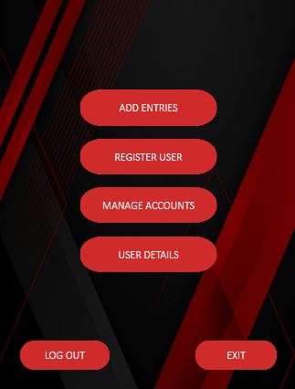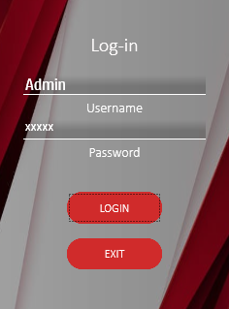

IV. Exporting to Excel

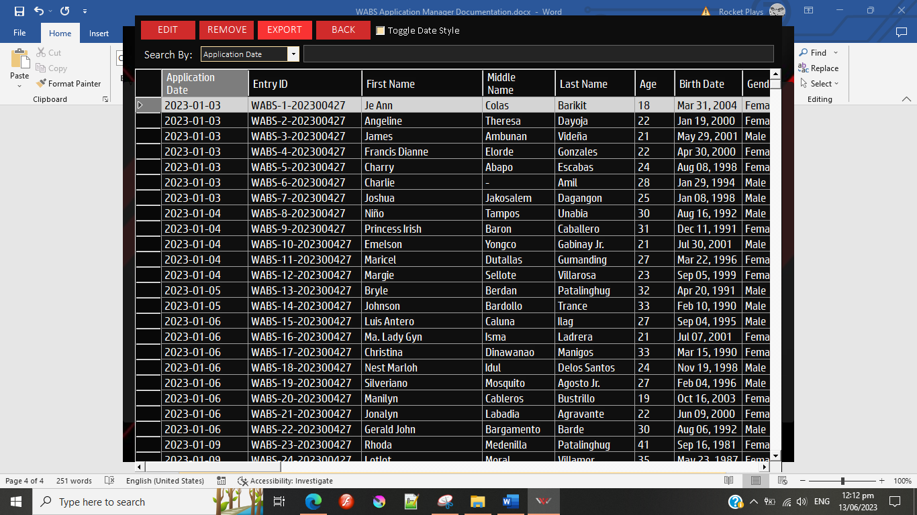 You can export the database into an Excel file. To do so, head over to the View Entries window and hit the Export button.

**IMPORTANT:** Make sure your copy of MS Excel is legitimate. Excel prevents the system from exporting if Excel’s product activation key is not supplied/verified.

V. Other Things to Note

1. Do not change the default account’s user type from **ADMIN** to **USER**. This will have unintended consequences and will revoke that account’s administrator privileges.
2. Keep at least 2 administrator accounts for back-up and redundancy.
3. Have at least one person (IT intern preferably) to maintain the database’s back-end using SQLite Database Browser.
   * SQLite Database Browser allows one to directly edit the database. This is useful in the event of a soft-lock where all ADMIN accounts have lost their administrator privileges, or if any other issues regarding the database arises.
   * Download SQLite DB Browser here: <https://sqlitebrowser.org/>

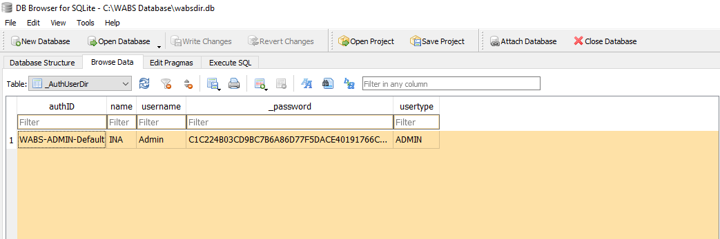

* The “usertype” field reads **ADMIN** and **USER** values only. Any other values will be ignored or will cause unintended issues. Change these values when a soft-lock occurs.
* Passwords are encrypted. They cannot be viewed as plain-text even with SQLite DB Browser.